**PLEASE POST**

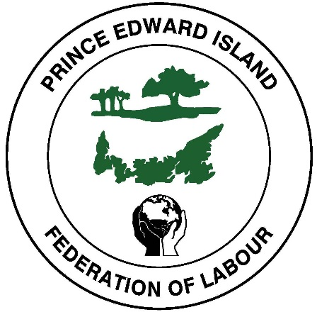

**MONDAY, SEPTEMBER 02, 2019**

**11:00 a.m. - 1:00 p.m.**

**at Joseph Ghiz Memorial Park, Charlottetown**

**Drop by as we celebrate Labour Day 2019!**

**There will be face painting, a magician and a bouncy house for children. Hot Dogs, Corn, French Fries and more will be served.**

**Please share this invitation with your members and their families.**

***For further information contact our office at (902) 368-3068 or peifed@pei.aibn.com***

**CARL PURSEY, PRESIDENT, PEIFL**

**PEI FEDERATION OF LABOUR’S**

**19TH ANNUAL LABOUR DAY**

**PICNIC AND BARBECUE**