Endless Savings & More (ESM)
Discounts on your smart phone
for CUPE PEI Members

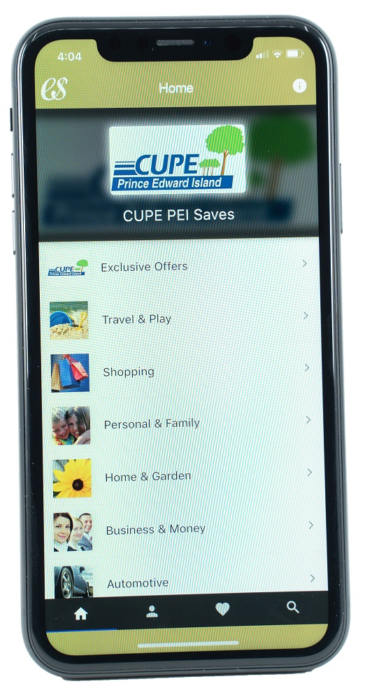
Download the CUPE PEI version of the ESM App to save on everyday purchases from hundreds of businesses including national chain retailers, service and travel providers.

To get the ESM App, go to your app store (Google or Apple). When you first download the ESM App, you will be asked for the “organization code” for CUPE PEI. It’s: cupepei

For complete details, view the
CUPE PEI Welcome Letter

